EJAVA Unit-5

Servlet

1. Explain the background and evolution of servlet technology. Discuss its significance in web development.

Servlet technology is a key component in Java-based web development, providing a robust framework for creating dynamic web applications. Its evolution can be traced back to the early days of the Java platform and the need for a more efficient and scalable way to generate dynamic content on the web.
- **CGI and Early Web Development**: Before servlets, the Common Gateway Interface (CGI) was the standard method for generating dynamic content on the web. However, CGI had several limitations, including performance overhead and lack of scalability, as it required the server to spawn a new process for each request.
- **Java Applets and Server-Side Java**: With the introduction of Java in the mid-1990s, developers began exploring ways to leverage Java's platform independence and object-oriented features for web development. Java applets allowed for client-side interactivity, but they had limitations, such as security restrictions and the need for browser plugins.
- **Java Servlets**: Servlets emerged as a solution to the shortcomings of CGI and Java applets. Developed by Sun Microsystems (now Oracle), servlets are Java classes that dynamically process and respond to requests from web clients. Servlets run on the server side, eliminating the need to spawn a new process for each request, thus improving performance and scalability.
- **Java Servlet API**: The Java Servlet API provides a standard interface for writing servlets and interacting with the web server. It defines classes and methods for handling HTTP requests and responses, session management, and other web-related tasks. The API has evolved over time, with new features and improvements added in each release.
- **Servlet Containers and Application Servers**: Servlets are typically deployed in servlet containers, which are part of web servers or application servers. Servlet containers manage the lifecycle of servlets, handling requests, managing resources, and providing other services. Application servers, which build upon servlet containers, offer additional features such as transaction management, security, and clustering.
- **Integration with Other Technologies**: Servlets can be integrated with other Java technologies such as JavaServer Pages (JSP), JavaServer Faces (JSF), and Java Persistence API (JPA) to create comprehensive web applications. This integration allows developers to separate presentation logic (in JSP or JSF) from business logic (in servlets) and interact with databases or other backend systems (using JPA).

**Significance in Web Development**:
- **Platform Independence**: Servlets are written in Java, which makes them platformindependent and compatible with a wide range of operating systems and web servers.
- **Performance and Scalability**: Servlets are more efficient than CGI because they run within the servlet container's process, eliminating the overhead of spawning new processes for each request. This makes servlet-based applications more scalable and suitable for high-traffic websites.

- **Rich API**: The Java Servlet API provides a rich set of features for handling HTTP requests, managing sessions, implementing security, and interacting with databases, making it easier for developers to build robust web applications.
- **Community Support**: Servlet technology is backed by a large and active community of developers, which means there are plenty of resources, libraries, and frameworks available to streamline the development process and solve common problems.
- **Enterprise Adoption**: Servlets are widely used in enterprise environments for building mission-critical web applications due to their stability, performance, and integration capabilities with other Java EE technologies.
In conclusion, servlet technology has played a significant role in the evolution of web development, offering a powerful and efficient framework for building dynamic, scalable, and platformindependent web applications. Its continued relevance and adoption demonstrate its importance in the ever-changing landscape of web development.

2. Describe the life cycle of a servlet in detail. Explain each phase and its significance.
The life cycle of a servlet refers to the series of steps that a servlet goes through from its initialization to its destruction. Understanding the servlet life cycle is crucial for developers to properly manage resources, handle requests, and maintain the state of the servlet throughout its lifetime. The servlet life cycle consists of the following phases:
1. **Loading**:
- **Initialization**: When a servlet container (such as Tomcat or Jetty) starts or when a request is received for the servlet for the first time, the container loads the servlet class into memory. The `init()` method of the servlet is then called by the container to perform any necessary initialization tasks, such as loading configuration parameters, establishing database connections, or initializing resources. The `init()` method is typically called only once during the servlet's lifetime, usually at the time of its creation.
2. **Instantiation**:
- **Object Creation**: After loading the servlet class, the servlet container creates an instance of the servlet class using its no-argument constructor. This instance will be used to handle multiple requests from clients. It's important to note that the container creates only one instance of each servlet class, regardless of the number of requests received.
3. **Request Handling**:
- **Service Method Invocation**: When a client sends a request to the servlet, the servlet container invokes the `service()` method of the servlet instance. The `service()` method examines the type of request (e.g., GET, POST, PUT) and calls the appropriate method (e.g., `doGet()`, `doPost()`) to handle the request. These methods contain the logic for processing the request, generating a response, and sending it back to the client. The `service()` method can be overridden by the servlet to customize request handling behavior.
4. **Concurrency**:
- **Thread Safety**: Servlet containers typically handle multiple requests concurrently by spawning multiple threads. It's essential for servlets to be thread-safe to handle concurrent requests properly. Developers must ensure that shared resources are accessed in a thread-safe manner to prevent race conditions and data corruption.
5. **Destroying**:
- **Destruction**: When the servlet container decides to remove the servlet instance from service (e.g., due to inactivity, server shutdown), it calls the `destroy()` method of the servlet. This method allows the servlet to perform any necessary cleanup tasks, such as releasing database connections, closing open files, or freeing resources. The `destroy()` method is called only once during the servlet's lifetime, just before the servlet instance is garbage-collected by the JVM.
6. **Reloading** (Optional):
- **Reloading**: Some servlet containers support dynamic reloading of servlets without restarting the entire container. In such cases, if changes are made to the servlet class file or its configuration, the servlet container can reload the servlet class, call its `init()` method again to reinitialize it, and put it back into service without interrupting the operation of other servlets or the container itself.

**Significance of Each Phase**:
- **Loading**: Initialization tasks are performed, such as setting up resources and configurations, which ensures that the servlet is ready to handle requests.
- **Instantiation**: The servlet instance is created, allowing it to handle multiple requests concurrently without interfering with other servlet instances.
- **Request Handling**: The core functionality of the servlet is executed, processing client requests, generating responses, and maintaining the servlet's state.
- **Concurrency**: Servlets must be thread-safe to handle concurrent requests properly and avoid data corruption or inconsistent behavior.
- **Destroying**: Cleanup tasks are performed, such as releasing resources and closing connections, ensuring that the servlet exits gracefully and frees up resources.
- **Reloading** (Optional): Supports dynamic updates to the servlet code or configuration without the need to restart the servlet container, facilitating development and maintenance activities.

Understanding the servlet life cycle is essential for developers to write efficient, scalable, and maintainable servlet-based web applications. Proper management of resources and state throughout the life cycle ensures the reliability and performance of servlets in handling client requests.
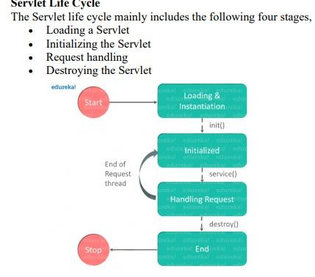

3.Write a simple servlet to demonstrate its basic functionality. Explain the steps involved in deploying and running a servlet.
Below is a simple servlet code to demonstrate its basic functionality. This servlet will receive a GET request, retrieve a parameter named "name" from the request, and respond with a personalized greeting.

```java import java.io.IOException; import java.io.PrintWriter; import javax.servlet.ServletException; import javax.servlet.http.HttpServlet; import javax.servlet.http.HttpServletRequest; import javax.servlet.http.HttpServletResponse;

public class GreetingServlet extends HttpServlet {
protected void doGet(HttpServletRequest request, HttpServletResponse response) throws ServletException, IOException {
// Retrieve the value of the parameter "name" from the request
String name = request.getParameter("name");
// Set the response content type response.setContentType("text/html");
// Get the PrintWriter object to write the HTML response
PrintWriter out = response.getWriter();
// Write the HTML response out.println("<html><head><title>Greeting Servlet</title></head><body>"); out.println("<h1>Hello, " + name + "!</h1>"); out.println("</body></html>");
}
}
To deploy and run this servlet, follow these steps:

- **Compile Servlet**: Compile the servlet code using a Java compiler (e.g., JDK's `javac` command). Make sure the servlet API JAR file (`servlet-api.jar` or `javax.servlet-api-x.x.x.jar`) is included in the classpath.
javac -cp path/to/servlet-api.jar GreetingServlet.java
- **Create WAR File**: Package the compiled servlet class along with any required resources (e.g., HTML, JSP files) into a Web Application Archive (WAR) file. The WAR file is a standard format for deploying servlet-based web applications.
jar cvf GreetingServlet.war GreetingServlet.class
- **Deploy WAR File**: Deploy the WAR file to a servlet container or application server (e.g., Apache Tomcat, Jetty). This typically involves copying the WAR file to a specific directory (e.g., `webapps` directory in Tomcat).
cp GreetingServlet.war /path/to/tomcat/webapps/
- **Start Servlet Container**: Start the servlet container or application server to deploy the WAR file. This process varies depending on the servlet container being used. For example, in Tomcat, you can start the server using the startup script.
/path/to/tomcat/bin/startup.sh (Linux)
/path/to/tomcat/bin/startup.bat (Windows)
- **Access Servlet**: Once the servlet container has started successfully, you can access the servlet using a web browser or a tool like cURL. Assuming the servlet is deployed at `http://localhost:8080/GreetingServlet`, you can access it with a URL like:
http://localhost:8080/GreetingServlet?name=John
This will display a personalized greeting for the name "John".
- **Undeploy Servlet** (Optional): If you want to undeploy the servlet, simply delete the WAR file from the servlet container's deployment directory. The servlet container will automatically undeploy the servlet and clean up any resources associated with it.
rm /path/to/tomcat/webapps/GreetingServlet.war

These steps demonstrate the process of deploying and running a servlet in a servlet container environment. It's essential to understand the servlet deployment process to develop and deploy servlet-based web applications effectively.

4.Discuss the Servlet API and its core packages, focusing on the javax.servlet package. Explain the purpose of key classes and interfaces.
The Servlet API is a collection of interfaces and classes provided by Java for developing servlet-based web applications. It defines a standard way for developers to write server-side programs that dynamically generate web content and respond to client requests. The core packages of the Servlet API include `javax.servlet` and `javax.servlet.http`.

### javax.servlet Package:
The `javax.servlet` package contains interfaces and classes that define the behavior of servlets and servlet containers. Some key classes and interfaces in this package include:
1. **Servlet Interface**:
- This interface defines the methods that all servlets must implement. Servlets typically extend the `GenericServlet` or `HttpServlet` classes instead of directly implementing this interface.
- Key methods:
- `init(ServletConfig config)`: Initializes the servlet. This method is called by the servlet container when the servlet is first loaded.
- `service(ServletRequest req, ServletResponse res)`: Handles client requests. This method is called by the servlet container to process each request.
- `destroy()`: Cleans up resources used by the servlet. This method is called by the servlet container when the servlet is being removed from service.
2. **ServletConfig Interface**:
- This interface provides configuration information to a servlet during its initialization.
- Key methods:
- `getInitParameter(String name)`: Retrieves the value of the initialization parameter with the given name from the servlet's configuration.
- `getServletContext()`: Returns a reference to the servlet context associated with the servlet.
3. **ServletContext Interface**:
- This interface represents the servlet context, which provides information about the web application and allows communication between servlets.
- Key methods:
- `getInitParameter(String name)`: Retrieves the value of the initialization parameter with the given name from the servlet context.
- `getRequestDispatcher(String path)`: Returns a `RequestDispatcher` object that acts as a wrapper for the resource located at the given path.
- `setAttribute(String name, Object obj)`: Sets an attribute in the servlet context.
- `getAttribute(String name)`: Retrieves the value of the attribute with the given name from the servlet context.
4. **ServletRequest Interface**:
- This interface represents an HTTP request from a client to the servlet container.
- Key methods:
- `getParameter(String name)`: Retrieves the value of a request parameter with the given name.
- `getRequestDispatcher(String path)`: Returns a `RequestDispatcher` object that acts as a wrapper for the resource located at the given path.
5. **ServletResponse Interface**:
- This interface represents an HTTP response from the servlet container to a client.
- Key methods:
- `getWriter()`: Returns a `PrintWriter` object that can be used to send character text to the client.
- `getOutputStream()`: Returns a `ServletOutputStream` object that can be used to send binary data to the client.
- `setContentType(String type)`: Sets the content type of the response.

These are some of the key classes and interfaces in the `javax.servlet` package. They form the foundation of servlet development, providing developers with the necessary tools to handle HTTP requests, generate responses, and interact with the servlet container and web application environment. Understanding these classes and interfaces is essential for building robust and scalable servlet-based web applications.
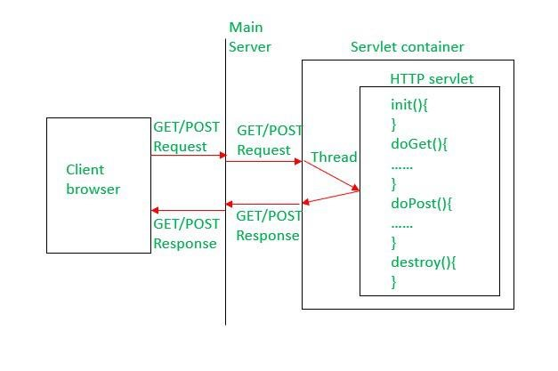

5.Explain how servlets can read request parameters. Provide examples to illustrate different methods of reading parameters.

Servlets can read request parameters sent by clients in various ways. These parameters can be included in the URL query string for GET requests or in the request body for POST requests. Servlets use the `HttpServletRequest` object to access request parameters. Here are different methods to read request parameters in servlets:

- **Using `getParameter(String name)` Method**:
The `getParameter()` method of the `HttpServletRequest` object is used to retrieve a single parameter value based on its name.
```java
protected void doGet(HttpServletRequest request, HttpServletResponse response) throws ServletException, IOException {
// Retrieve a parameter named "username"
String username = request.getParameter("username");

// Process the parameter value
// ... }
- **Using `getParameterValues(String name)` Method**:
If a parameter can have multiple values (e.g., checkboxes with the same name), you can use the `getParameterValues()` method to retrieve all values as an array of strings.
```java
protected void doPost(HttpServletRequest request, HttpServletResponse response) throws ServletException, IOException {
// Retrieve multiple values of a parameter named "interests"
String[] interests = request.getParameterValues("interests");

// Process the parameter values
// ...
}
- **Using `getParameterMap()` Method**:
The `getParameterMap()` method returns a map containing all request parameters, where the parameter names are keys and the parameter values are arrays of strings.
```java
protected void doGet(HttpServletRequest request, HttpServletResponse response) throws ServletException, IOException {
// Retrieve all request parameters as a map
Map<String, String[]> paramMap = request.getParameterMap();
// Process the parameter map for (Map.Entry<String, String[]> entry : paramMap.entrySet()) {
String paramName = entry.getKey();
String[] paramValues = entry.getValue();
// Process each parameter name-value pair
}
}

4. **Using `getQueryString()` Method**:
For GET requests, you can use the `getQueryString()` method to retrieve the entire query string from the URL, including all parameters.
```java
protected void doGet(HttpServletRequest request, HttpServletResponse response) throws ServletException, IOException {
// Retrieve the entire query string
String queryString = request.getQueryString();
// Parse the query string to extract parameters
}
These are some common methods for reading request parameters in servlets. Depending on the requirements of your application, you can choose the appropriate method to retrieve parameters and process them accordingly. Remember to handle null checks and validate user input to ensure the security and reliability of your servlets.
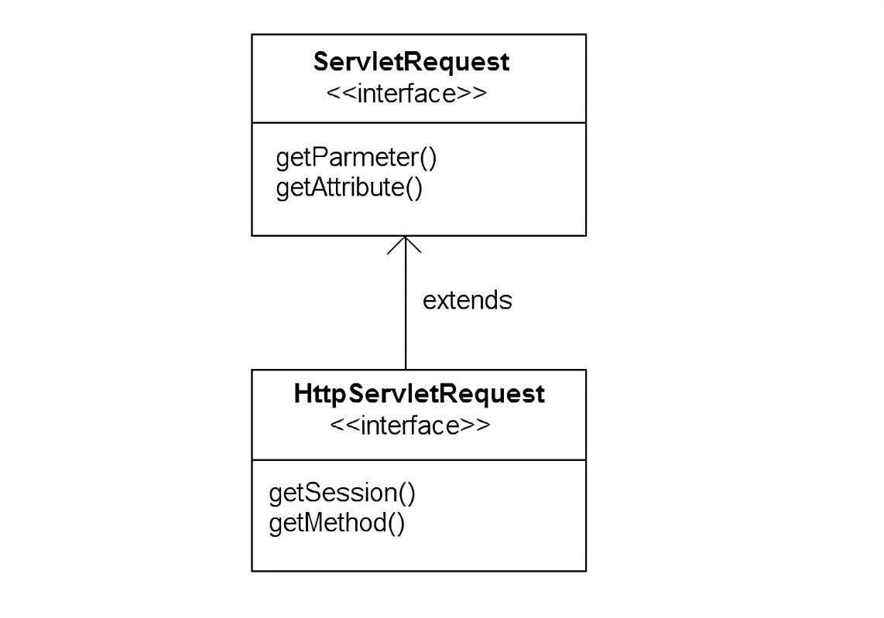

6.Discuss the javax.servlet.http package and its role in handling HTTP requests and responses. Explain key classes and interfaces involved.

The `javax.servlet.http` package is an extension of the `javax.servlet` package and is specifically designed for handling HTTP requests and responses in servlet-based web applications. It provides additional functionality and convenience methods for working with HTTP-specific features such as sessions, cookies, and headers. Key classes and interfaces in the `javax.servlet.http` package include:
1. **HttpServletRequest Interface**:
- Extends the `ServletRequest` interface to provide additional methods for handling HTTP-specific features.
- Key methods:
- `getCookies()`: Returns an array of `Cookie` objects representing cookies sent by the client. - `getMethod()`: Returns the HTTP method (GET, POST, etc.) of the request.
- `getSession()`: Returns the session associated with the request, optionally creating one if it doesn't exist.
- `getHeader(String name)`: Returns the value of the specified request header.
2. **HttpServletResponse Interface**:
- Extends the `ServletResponse` interface to provide additional methods for working with HTTPspecific response features.
- Key methods:
- `addCookie(Cookie cookie)`: Adds a `Cookie` object to the response headers.
- `setStatus(int sc)`: Sets the status code of the response.
- `sendRedirect(String location)`: Sends a temporary redirect response to the client with the specified location URL.
- `setHeader(String name, String value)`: Sets a response header with the given name and value.
3. **HttpServlet Class**:
- Abstract class that simplifies the process of writing HTTP servlets by providing default implementations for common HTTP request methods (e.g., GET, POST, PUT, DELETE).
- Developers can extend this class and override specific methods to handle different types of HTTP requests.
- Key methods to override:
- `doGet(HttpServletRequest request, HttpServletResponse response)`: Handles GET requests.
- `doPost(HttpServletRequest request, HttpServletResponse response)`: Handles POST requests.
- Other `doXxx()` methods for handling different HTTP methods.
4. **HttpSession Interface**:
- Represents a session between the server and a client, allowing servlets to maintain stateful information across multiple requests from the same client.
- Key methods:
- `setAttribute(String name, Object value)`: Stores an attribute in the session.
- `getAttribute(String name)`: Retrieves the value of an attribute from the session.
- `invalidate()`: Invalidates the session, removing all session data and ending the session.
5. **Cookie Class**:
- Represents an HTTP cookie, which is a small piece of data sent by the server and stored on the client's machine.
- Key methods:
- `Cookie(String name, String value)`: Constructor to create a new cookie with the specified name and value.
- `setMaxAge(int expiry)`: Sets the maximum age of the cookie (in seconds).
- `setPath(String path)`: Sets the path on the server for which the cookie is sent.

These are some of the key classes and interfaces in the `javax.servlet.http` package. They play a crucial role in handling HTTP requests and responses in servlet-based web applications, providing developers with the necessary tools to work with HTTP-specific features such as sessions, cookies, and headers. Understanding these classes and interfaces is essential for building robust and featurerich servlet-based web applications.
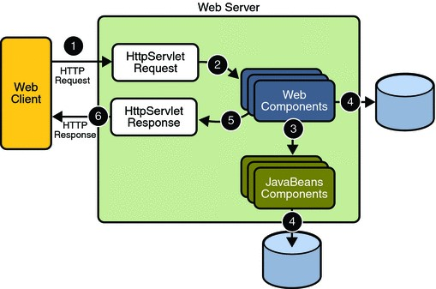
7.Describe the use of cookies in servlets. Explain how cookies are created, read, and manipulated within servlets.

Cookies are small pieces of data sent by a web server to a web browser and stored locally on the client's machine. They are commonly used in servlet-based web applications to maintain user sessions, personalize user experiences, and track user behavior across multiple requests. Servlets can create, read, and manipulate cookies to store and retrieve information between client and server interactions.
### Creating Cookies:
Servlets can create cookies and send them to the client's browser using the `HttpServletResponse` object. Here's how to create a cookie in a servlet:
```java
Cookie cookie = new Cookie("username", "JohnDoe"); cookie.setMaxAge(3600); // Set the cookie's maximum age in seconds response.addCookie(cookie); // Add the cookie to the response
```
### Reading Cookies:
Servlets can retrieve cookies sent by the client's browser using the `HttpServletRequest` object. Here's how to read cookies in a servlet:
```java
Cookie[] cookies = request.getCookies();
if (cookies != null) { for (Cookie cookie : cookies) {
String name = cookie.getName();
String value = cookie.getValue();
// Process the cookie's name and value
}
}
### Manipulating Cookies:
Servlets can manipulate cookies by modifying their attributes, such as value, maximum age, and path. Here are some common manipulations:
- **Setting Cookie Value**:
```java
Cookie cookie = new Cookie("username", "JaneDoe");
response.addCookie(cookie); // Update the cookie's value
- **Setting Maximum Age**:
```java
Cookie cookie = new Cookie("username", "JohnDoe"); cookie.setMaxAge(3600); // Set the cookie's maximum age to 1 hour response.addCookie(cookie);
- **Deleting Cookies**:
To delete a cookie, set its maximum age to 0 and add it to the response. The browser will remove the cookie.
```java
Cookie cookie = new Cookie("username", ""); cookie.setMaxAge(0); // Set the cookie's maximum age to 0 to delete it response.addCookie(cookie);
### Security Considerations:
- **Sensitive Information**: Avoid storing sensitive information in cookies as they are stored on the client's machine and can be accessed or manipulated.
- **Encryption**: If sensitive information needs to be stored, encrypt the data before storing it in cookies to enhance security.
- **Cookie Attributes**: Set appropriate attributes such as `HttpOnly` and `Secure` to mitigate security risks associated with cookies.
### Use Cases:
- **Session Management**: Cookies are commonly used to maintain user sessions by storing session identifiers.
- **Remember Me Functionality**: Cookies can be used to remember user preferences or login credentials.
- **Tracking User Behavior**: Cookies can track user interactions and preferences to personalize content or provide targeted advertisements.

In summary, cookies play a vital role in servlet-based web applications for maintaining state, personalizing user experiences, and tracking user behavior. Servlets can create, read, and manipulate cookies to store and retrieve information between client and server interactions, enhancing the functionality and usability of web applications. However, developers should be mindful of security considerations when working with cookies to ensure the protection of user data and privacy.
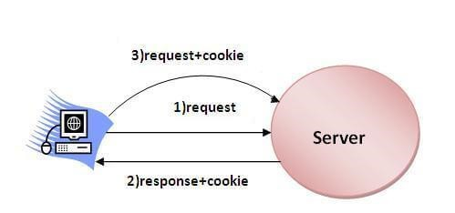

8.Explain the concept of session objects in servlets. Discuss their role in maintaining user state across multiple requests
In servlet-based web applications, session objects are used to maintain stateful information about a user across multiple HTTP requests and responses. A session object is associated with a specific user and is created by the servlet container when the user first interacts with the web application. The session object persists throughout the user's interaction with the application, allowing servlets to store and retrieve user-specific data.
### Role of Session Objects:
- **State Management**:
Session objects enable the web application to maintain stateful information about a user's interaction, such as login credentials, shopping cart items, user preferences, or any other userspecific data. This information can be stored in the session object and accessed across multiple requests.
- **User Identification**:
Session objects help identify individual users interacting with the web application. When a user first accesses the application, the servlet container assigns a unique session identifier (session ID) to the user, which is typically stored as a cookie in the user's browser. This session ID is used to associate subsequent requests from the same user with the corresponding session object.
- **Session Tracking**:
Session objects facilitate session tracking, allowing servlets to associate subsequent requests from the same user with the appropriate session object. This enables the web application to maintain user state and provide personalized experiences based on the user's interactions.
### How Session Objects Work:
- **Session Creation**:
When a user first accesses the web application, the servlet container creates a new session object and assigns a unique session ID to the user. This session ID is typically sent to the user's browser as a cookie, although other mechanisms such as URL rewriting can also be used.
- **Session Retrieval**:
Subsequent requests from the same user include the session ID, allowing the servlet container to associate the request with the appropriate session object. Servlets can retrieve the session object associated with the current request using the `getSession()` method of the `HttpServletRequest` object.
HttpSession session = request.getSession();
- **Data Storage and Retrieval**:
Servlets can store and retrieve user-specific data in the session object using key-value pairs. This data persists across multiple requests and can be accessed by any servlet within the same session.
// Storing data in the session session.setAttribute("username", "JohnDoe");
// Retrieving data from the session
String username = (String) session.getAttribute("username");
- **Session Invalidation**:
Sessions can be invalidated either programmatically by calling the `invalidate()` method on the session object or automatically by the servlet container based on session timeout settings. Invalidating a session removes all data associated with the session and releases any resources held by the session object. session.invalidate();
### Importance in Maintaining User State:
Session objects are essential for maintaining user state across multiple requests in servlet-based web applications. They allow the application to identify and track individual users, store user-specific data, and provide personalized experiences. By persisting user state throughout the user's interaction with the application, session objects play a crucial role in enhancing the functionality and usability of web applications. Developers must understand and utilize session objects effectively to build robust and stateful web applications.
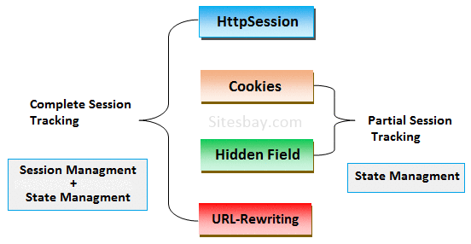

SpringBoot

1. Enumerate the advantages of using Spring Boot for developing Java applications. Discuss how Spring Boot simplifies application development and deployment.

Spring Boot is a popular framework for developing Java applications, offering several advantages that simplify application development and deployment. Here are some key advantages of using Spring Boot:
- **Ease of Setup and Configuration**:
Spring Boot provides a convention-over-configuration approach, reducing the need for manual configuration. It comes with sensible defaults and auto-configuration, allowing developers to quickly bootstrap a new project without spending time on boilerplate code and configuration.
- **Embedded Servers**:
Spring Boot includes embedded servers like Tomcat, Jetty, or Undertow, eliminating the need for deploying applications to standalone servers. This simplifies deployment and makes the application self-contained, allowing it to run as a standalone JAR file.
- **Dependency Management**:
Spring Boot simplifies dependency management through its dependency management plugin. It manages version conflicts and ensures that compatible versions of dependencies are used, reducing compatibility issues and making dependency management more manageable.
- **Auto-Configuration**:
Spring Boot's auto-configuration feature automatically configures Spring beans based on the dependencies present in the classpath. This reduces the need for manual configuration and helps in quickly getting started with development.
- **Starter POMs**:
Spring Boot provides a collection of starter POMs (Project Object Model) that contain preconfigured dependencies for common use cases like web applications, database access, security, messaging, etc. These starter POMs streamline project setup by providing the necessary dependencies with minimal configuration.
- **Actuator**:
Spring Boot Actuator provides monitoring and management capabilities for Spring Boot applications. It includes built-in endpoints for monitoring application health, metrics, environment details, and more. Actuator simplifies operational tasks and allows developers to monitor application behavior without additional configuration.
- **Spring Ecosystem Integration**:
Spring Boot seamlessly integrates with the wider Spring ecosystem, including Spring Framework, Spring Data, Spring Security, and others. This allows developers to leverage existing Spring components and libraries to build robust and feature-rich applications.
- **Simplified Deployment**:
With embedded servers and self-contained JAR files, deploying Spring Boot applications is straightforward. Developers can package the application as a JAR file and deploy it to any environment with Java installed, without worrying about configuring external servers or containers.
- **Community Support and Documentation**:
Spring Boot has a large and active community of developers, providing ample resources, tutorials, and documentation. Developers can quickly find solutions to common problems, participate in forums, and access community-contributed libraries and extensions.

In summary, Spring Boot offers significant advantages for developing Java applications by simplifying setup, configuration, dependency management, and deployment. Its convention-over-configuration approach, embedded servers, auto-configuration, and integration with the wider Spring ecosystem make it a popular choice for building modern and scalable Java applications.
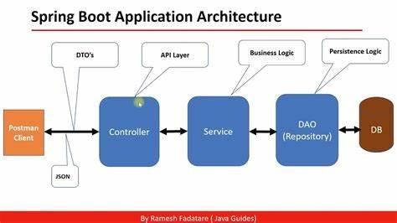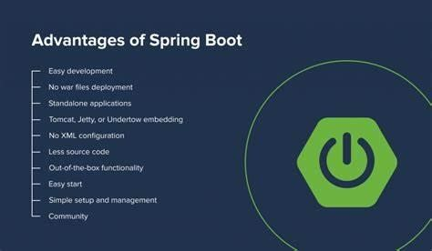

2. | Explain the key features of Spring Boot.
Spring Boot is a powerful framework for building Java-based applications, offering a wide range of features that simplify development, configuration, and deployment. Here are some key features of Spring Boot:
- **Auto-Configuration**:
Spring Boot provides auto-configuration, which automatically configures Spring beans based on the dependencies present in the classpath. It analyzes the project's dependencies and environment to provide sensible defaults, reducing the need for manual configuration.
- **Starter POMs**:
Spring Boot offers a collection of starter POMs (Project Object Model) that contain preconfigured dependencies for common use cases such as web applications, database access, security, messaging, etc. These starter POMs streamline project setup by providing the necessary dependencies with minimal configuration.
- **Embedded Servers**:
Spring Boot includes embedded servers like Tomcat, Jetty, or Undertow, allowing applications to run as standalone JAR files without requiring external servers or containers. Embedded servers simplify deployment and make the application self-contained.
- **Spring Boot Actuator**:
Spring Boot Actuator provides monitoring and management capabilities for Spring Boot applications. It includes built-in endpoints for monitoring application health, metrics, environment details, and more. Actuator simplifies operational tasks and allows developers to monitor application behavior without additional configuration.
- **DevTools**:
Spring Boot DevTools provides development-time features such as automatic application restarts, live reloading of changes, and remote debugging. DevTools improve developer productivity by reducing the turnaround time for code changes during development.
- **Spring Boot CLI**:
Spring Boot CLI (Command Line Interface) allows developers to quickly bootstrap, develop, and test Spring Boot applications from the command line. It provides features such as auto-restart, embedded Groovy support, and script-based application configuration.
- **Spring Boot Starters**:
Spring Boot Starters are a set of dependency descriptors that simplify the configuration of Spring applications. They provide a convenient way to add dependencies for specific features or integrations, reducing the need for manual dependency management.
- **Production-Ready Features**:
Spring Boot includes production-ready features such as health checks, metrics, security, and externalized configuration out of the box. These features ensure that Spring Boot applications are robust, scalable, and suitable for production environments without additional configuration.
- **Externalized Configuration**:
Spring Boot allows configuration properties to be externalized from the application code using property files, YAML files, environment variables, or command-line arguments. Externalized configuration simplifies environment-specific configuration and promotes best practices for managing configuration in different deployment environments.
- **Integration with Spring Ecosystem**:
Spring Boot seamlessly integrates with the wider Spring ecosystem, including Spring Framework, Spring Data, Spring Security, and others. This allows developers to leverage existing Spring components and libraries to build robust and feature-rich applications.

These are some of the key features of Spring Boot that make it a popular choice for building modern and scalable Java applications. Its focus on convention-over-configuration, simplicity, and productivity enhancements streamline development and deployment processes, allowing developers to focus on building high-quality software.
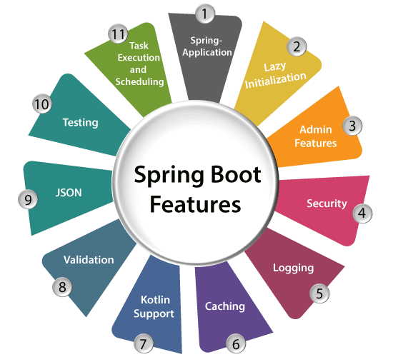
3. Describe the architecture of a typical Spring Boot application. Explain the role of various components.
A typical Spring Boot application follows a layered architecture pattern, which organizes the application into logical layers, each responsible for a specific aspect of the application's functionality. The architecture of a Spring Boot application typically consists of the following components:
. **Presentation Layer**:
The presentation layer, also known as the web layer, is responsible for handling client requests and generating responses. It typically consists of the following components:
- **Controllers**: Controllers are responsible for processing incoming HTTP requests, invoking the appropriate business logic, and returning the HTTP responses. In a Spring Boot application, controllers are typically annotated with `@Controller` or `@RestController` annotations.
- **Views**: Views are responsible for generating the HTML or other content to be returned to the client. In Spring Boot applications, views are often implemented using template engines like Thymeleaf, FreeMarker, or Mustache.
- **Service Layer**:
The service layer contains the business logic of the application. It encapsulates applicationspecific logic and coordinates the execution of tasks required to fulfill client requests. The service layer typically consists of the following components:
  - **Service Classes**: Service classes implement the business logic of the application. They contain methods that perform specific tasks or operations required by the application.
- **Data Access Layer**:
The data access layer is responsible for interacting with the database or other data sources. It abstracts the details of data access and provides a consistent interface for accessing and manipulating data. The data access layer typically consists of the following components:
  - **Repositories**: Repositories are responsible for encapsulating data access logic and providing CRUD (Create, Read, Update, Delete) operations for interacting with the database. In Spring Boot applications, repositories are often implemented using Spring Data JPA, which provides a repository abstraction over JPA (Java Persistence API).
  - **Entities**: Entities represent the domain objects or data model of the application. They typically correspond to database tables and encapsulate data and behavior related to specific business entities.
- **Configuration Layer**:
The configuration layer is responsible for configuring and bootstrapping the Spring Boot application. It typically consists of the following components:
  - **Application Configuration**: Application configuration is managed using property files, YAML files, environment variables, or command-line arguments. Spring Boot provides externalized configuration support, allowing developers to configure application properties without modifying the source code.
  - **Bean Configuration**: Bean configuration is done using Java-based configuration (using `@Configuration` classes), XML-based configuration, or component scanning. Spring Boot uses autoconfiguration to automatically configure Spring beans based on the dependencies present in the classpath.
- **External Systems Integration Layer**:
The external systems integration layer is responsible for integrating with external services or systems, such as web services, messaging systems, or third-party APIs. It typically consists of the following components:
  - **Integration Components**: Integration components are responsible for communicating with external systems and processing data exchanged between the application and external services. Spring Boot provides integration support through various modules like Spring Web Services, Spring Integration, and Spring AMQP (Advanced Message Queuing Protocol).

Overall, the architecture of a typical Spring Boot application follows a modular and layered approach, with each component responsible for a specific aspect of the application's functionality. This architecture promotes separation of concerns, modularity, and maintainability, making it easier to develop, test, and maintain Spring Boot applications.
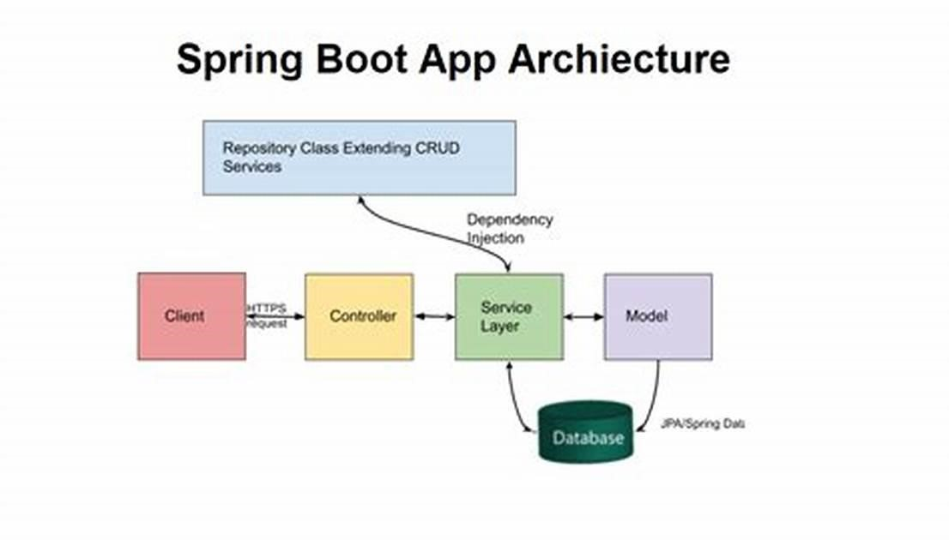

4. Discuss the Spring Initializer tool and its significance in creating Spring Boot projects. Explain how to use Spring Initializer to bootstrap a new Spring Boot project.

The Spring Initializr is a web-based tool provided by the Spring team to bootstrap and generate Spring Boot projects quickly. It allows developers to configure project settings, select dependencies, and download a pre-configured project structure as a ZIP file. The Spring Initializr significantly simplifies the process of creating new Spring Boot projects by providing a user-friendly interface for project setup.
### Significance of Spring Initializr:
- **Rapid Project Setup**:
Spring Initializr allows developers to quickly set up new Spring Boot projects by selecting project metadata (e.g., project name, description, package name) and choosing dependencies from a curated list of available starters.
- **Customizable Configuration**:
Developers can customize project settings and dependencies based on their specific requirements. They can choose from a wide range of starters for web applications, data access, messaging, security, testing, and more.
- **Generated Project Structure**:
The Spring Initializr generates a pre-configured project structure with Maven or Gradle build files, a default application class, configuration files, and dependency management settings. This saves developers time and effort in setting up the initial project structure manually.
- **Version Compatibility**:
Spring Initializr ensures compatibility between Spring Boot versions and dependencies, preventing version conflicts and ensuring that the generated project is compatible with the selected Spring Boot version.
### Using Spring Initializr:
To bootstrap a new Spring Boot project using Spring Initializr, follow these steps:
- **Access Spring Initializr Website**:
Open a web browser and navigate to the Spring Initializr website: [https://start.spring.io](https://start.spring.io).
- **Configure Project Metadata**:
  - Enter the project metadata, including group, artifact, name, and description.
  - Choose the appropriate project metadata settings based on your project requirements.
- **Select Dependencies**:
  - Select the dependencies required for your project from the list of available starters. You can search for starters by name or category.
  - Choose dependencies for web applications, data access, messaging, security, testing, etc., based on your project needs.
- **Choose Build Tool**:
  - Select the desired build tool (Maven or Gradle) for your project.
  - Choose the build tool version and customize additional build settings if necessary.
- **Generate Project**:
  - Click on the "Generate" button to generate the Spring Boot project based on the selected configuration.
  - Once the project is generated, you will be prompted to download the project as a ZIP file.
- **Import Project into IDE**:
  - Extract the downloaded ZIP file to a location on your local machine.
  - Import the project into your preferred Integrated Development Environment (IDE) such as IntelliJ IDEA, Eclipse, or Visual Studio Code.
  - Build and run the project to verify that it is set up correctly.

By following these steps, you can easily bootstrap a new Spring Boot project using the Spring Initializr tool, saving time and effort in setting up the initial project structure and configuration manually.
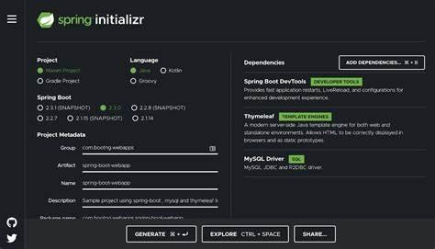
5. Walk through the steps involved in creating a Spring Boot project from scratch.
Discuss the necessary dependencies, project structure, and configuration files.

Creating a Spring Boot project from scratch involves several steps, including setting up the project structure, configuring dependencies, and creating necessary configuration files. Below is a walkthrough of the steps involved:
### Step 1: Set up Project Structure
- **Create a New Maven or Gradle Project**:
  - Use your preferred build tool (Maven or Gradle) to create a new project.
  - In this example, let's create a Maven project using the following Maven command:
```
mvn archetype:generate -DgroupId=com.example -DartifactId=my-spring-boot-app DarchetypeArtifactId=maven-archetype-quickstart -DinteractiveMode=false
```
- **Navigate to Project Directory**:
  - Move to the directory of the newly created project.
### Step 2: Add Spring Boot Starter Dependencies
1. **Open `pom.xml` (for Maven) or `build.gradle` (for Gradle)**:
- Add Spring Boot starter dependencies according to your project requirements.
- For example, to create a basic web application, add the `spring-boot-starter-web` dependency.
For Maven (`pom.xml`):
```xml
<dependencies>
<dependency>
<groupId>org.springframework.boot</groupId>
<artifactId>spring-boot-starter-web</artifactId>
</dependency>
</dependencies>
```
For Gradle (`build.gradle`):
```groovy dependencies { implementation 'org.springframework.boot:spring-boot-starter-web'
}
```
### Step 3: Create Application Entry Point
1. **Create a Main Application Class**:
- Create a main application class with a `main` method. This class will serve as the entry point for the Spring Boot application.
- Annotate the class with `@SpringBootApplication`.
```java
import org.springframework.boot.SpringApplication; import org.springframework.boot.autoconfigure.SpringBootApplication; @SpringBootApplication
public class MySpringBootApplication { public static void main(String[] args) {
SpringApplication.run(MySpringBootApplication.class, args);
}
}
```
### Step 4: Configuration (Optional)
1. **Application Properties or YAML**:
- Optionally, configure application properties or YAML files to customize application settings such as server port, database configuration, etc.
Example `application.properties`:
```properties # Server port server.port=8080
```
Example `application.yml`:
```yaml # Server port server:
port: 8080
```
### Step 5: Build and Run the Application
- **Build the Project**:
  - Use Maven or Gradle to build the project.
For Maven:
```
mvn clean install
```
For Gradle:
```
./gradlew build
```
- **Run the Application**:
  - Run the Spring Boot application using the main application class created earlier.
For Maven:
```
mvn spring-boot:run
```
For Gradle:
```
./gradlew bootRun
```
### Step 6: Access the Application
1. **Access the Application**:
- Once the application is running, access it in a web browser or using a tool like cURL.
- By default, the application will run on the configured server port (e.g., `http://localhost:8080`).
### Step 7: Further Development
1. **Add Additional Functionality**:
- Continue developing the Spring Boot application by adding controllers, services, repositories, and other components as needed for your project requirements.
- Configure additional dependencies and settings as required for your specific use case.
By following these steps, you can create a Spring Boot project from scratch, configure dependencies, set up the project structure, and run the application. Spring Boot's convention-over-configuration approach and auto-configuration capabilities streamline the development process, allowing you to focus on building features and functionality for your application.

6.Explain the components of a typical Spring Boot project, including controllers, services, repositories, and configuration classes. Discuss the responsibilities of each component
A typical Spring Boot project is structured into various components, each with specific responsibilities in the application. Here are the key components of a typical Spring Boot project:
1. **Controllers**:
- **Responsibility**: Controllers are responsible for handling incoming HTTP requests from clients and generating HTTP responses. They serve as the entry point for requests and delegate processing to appropriate service classes.
- **Key Characteristics**:
- Annotated with `@Controller` or `@RestController` annotations.
- Define handler methods to process requests and return responses.
- Use `@RequestMapping`, `@GetMapping`, `@PostMapping`, etc., annotations to map requests to handler methods.
- Inject service components or other dependencies as needed.
- **Example**:
```java
@RestController public class UserController {
@Autowired private UserService userService; @GetMapping("/users/{id}") public ResponseEntity<User> getUserById(@PathVariable Long id) { User user = userService.getUserById(id); return ResponseEntity.ok(user);
}
// Other handler methods...
}
2. **Services**:
- **Responsibility**: Services contain business logic and perform operations requested by controllers. They encapsulate application-specific functionality and coordinate interactions with repositories and other services.
- **Key Characteristics**:
- Annotated with `@Service` annotation.
- Define methods to implement business logic and perform operations.
- Encapsulate complex business rules and interactions with data access components.
- Use repositories or other services to access data as needed.
- **Example**:
```java
@Service public class UserService { @Autowired private UserRepository userRepository; public User getUserById(Long id) { return userRepository.findById(id)
.orElseThrow(() -> new EntityNotFoundException("User not found with id: " + id));
}
// Other service methods...
}
3. **Repositories**:
- **Responsibility**: Repositories are responsible for interacting with the database or other data sources. They provide methods for CRUD (Create, Read, Update, Delete) operations on domain entities.
- **Key Characteristics**:
- Annotated with `@Repository` annotation.
- Extend Spring Data interfaces like `CrudRepository` or `JpaRepository`.
- Define methods to query and manipulate data in the underlying database.
- Provide a high-level abstraction over data access operations.
- **Example**:

```java
@Repository public interface UserRepository extends JpaRepository<User, Long> { // Additional query methods can be defined here
}
4. **Configuration Classes**:
- **Responsibility**: Configuration classes are used to configure various aspects of the Spring Boot application, such as beans, components, data sources, security, and other settings.
- **Key Characteristics**:
- Annotated with `@Configuration` annotation.
- Define bean configuration methods using `@Bean` annotation.
- Customize application settings using `@Value` annotation or externalized configuration.
- Configure Spring Security, database connections, logging, etc., as needed.
- **Example**:
```java
@Configuration public class AppConfig {
@Bean
public DataSource dataSource() { // Define and configure data source return new DataSource();
}
@Bean
public SomeService someService() {
// Define and configure some service bean return new SomeService();
}
// Other configuration methods...
}

These components work together to build a robust and maintainable Spring Boot application. Controllers handle incoming HTTP requests, services implement business logic, repositories interact with the database, and configuration classes customize application behavior. This modular and layered architecture promotes separation of concerns, testability, and maintainability, making it easier to develop and scale Spring Boot applications.
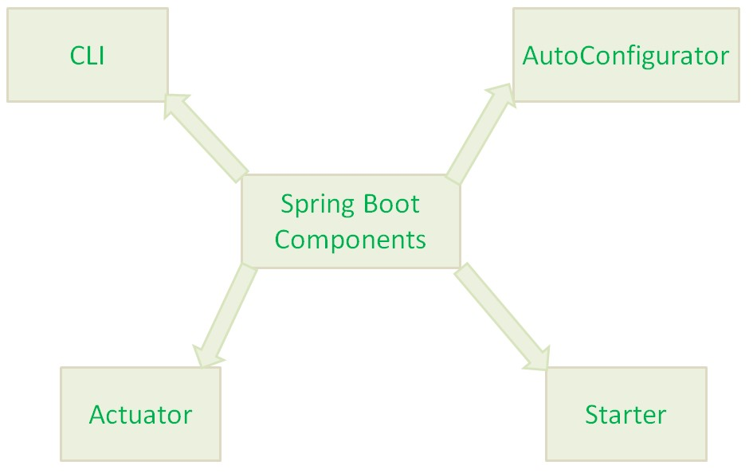

7.Discuss the integration of databases with Spring Boot applications. Explain how Spring Boot simplifies database access and management.

Integrating databases with Spring Boot applications is a common requirement for many modern software projects. Spring Boot simplifies this integration by providing various tools and libraries that streamline database access and management. Below, I'll discuss how Spring Boot facilitates this integration and simplifies database access:
- **Dependency Management**: Spring Boot simplifies dependency management through its builtin dependency management feature. Developers can easily include dependencies for popular databases such as MySQL, PostgreSQL, MongoDB, etc., in their `pom.xml` or `build.gradle` files. These dependencies automatically configure the required drivers and settings for database connectivity.
- **Auto-Configuration**: Spring Boot's auto-configuration feature eliminates the need for developers to manually configure data source beans for database connections. It automatically detects the presence of database-related dependencies and configures the data source accordingly. Developers only need to provide minimal configuration properties such as database URL, username, and password.
- **Spring Data JPA**: Spring Boot seamlessly integrates with Spring Data JPA, which provides a higher-level abstraction for working with relational databases. With Spring Data JPA, developers can define repository interfaces for database entities, and Spring Boot automatically generates the necessary CRUD (Create, Read, Update, Delete) operations based on method names. This eliminates the boilerplate code traditionally associated with database access layers.
- **Embedded Databases**: Spring Boot allows developers to use embedded databases like H2, HSQLDB, and Derby for development and testing purposes. These databases can be easily configured and initialized using Spring Boot's properties, without requiring any external database installation. This feature is particularly useful for rapid prototyping and testing.
- **Transaction Management**: Spring Boot simplifies transaction management through its integration with Spring's declarative transaction management framework. Developers can annotate service methods with `@Transactional` to specify transactional behavior, and Spring Boot takes care of managing transactions, including rollback handling in case of exceptions.
- **Database Migrations**: Spring Boot supports database migration tools such as Flyway and Liquibase, which enable developers to manage database schema changes over time. These tools integrate seamlessly with Spring Boot applications, allowing developers to version-control database schema changes and apply them automatically during application startup.
- **Configuration Properties**: Spring Boot provides a convenient way to configure database properties using external configuration files (e.g., `application.properties` or `application.yml`). Developers can specify database connection details, pool configurations, and other settings in these files, making it easy to manage different configurations for different environments (e.g., development, testing, production).
- **Monitoring and Management**: Spring Boot Actuator provides endpoints for monitoring and managing the application, including database-related metrics and health checks. Developers can easily monitor database connection pools, query execution statistics, and other relevant metrics using Actuator endpoints.
Overall, Spring Boot simplifies database integration by providing auto-configuration, higher-level abstractions, and seamless integration with popular database technologies. This allows developers to focus more on business logic and less on infrastructure concerns when building database-driven applications.
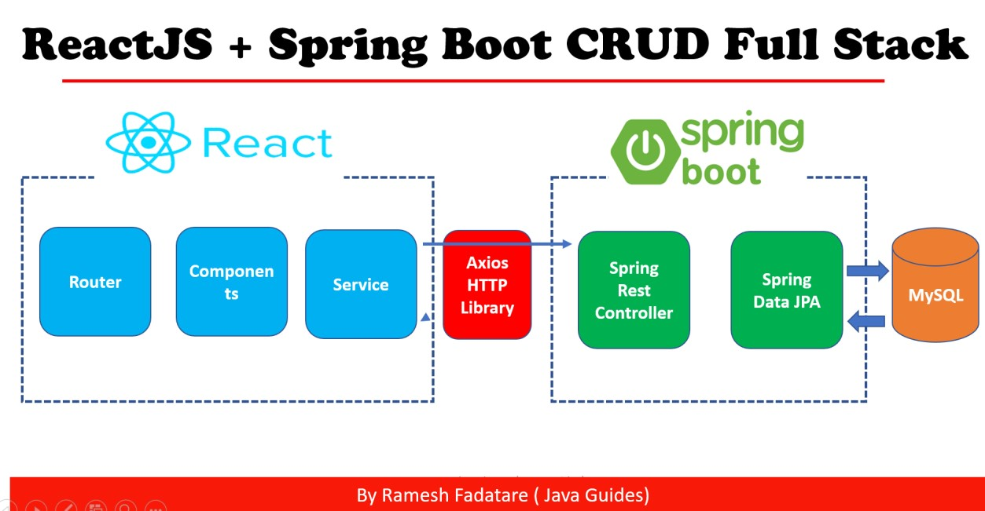

8.Explain how Spring Boot handles views and templates for rendering HTML pages. Discuss popular view technologies supported by Spring Boot, such as Thymeleaf and FreeMarker
Spring Boot provides a flexible and efficient way to render HTML pages by integrating with various view technologies. These view technologies allow developers to generate dynamic HTML content that can be displayed in web browsers. Two popular view technologies supported by Spring Boot are Thymeleaf and FreeMarker.
1. **Thymeleaf**:
- **Overview**: Thymeleaf is a modern server-side Java template engine for web and standalone environments. It enables natural templates that can be processed both in web and non-web environments, such as batch processing or unit testing.
- **Integration with Spring Boot**: Spring Boot provides seamless integration with Thymeleaf through its starter dependencies. Developers can include the `spring-boot-starter-thymeleaf` dependency in their project, and Spring Boot automatically configures Thymeleaf for HTML rendering.
- **Features**:
- Thymeleaf supports a wide range of features, including expression language (Thymeleaf Expression Language or Thymeleaf-EL), iteration, conditionals, template layouts, and internationalization.
- It promotes natural templates where HTML files are valid HTML5 documents, allowing developers to view and edit them directly in web browsers.
- Thymeleaf templates can be processed both server-side and client-side, making it versatile for different use cases.
- **Example Configuration**:
```xml
<dependency>
<groupId>org.springframework.boot</groupId>
<artifactId>spring-boot-starter-thymeleaf</artifactId>
</dependency>
```
- **Usage**:
- Developers can create HTML templates using Thymeleaf syntax, which includes attributes prefixed with `th:` to perform various operations such as rendering dynamic data, iterating over collections, conditionals, etc.
- Thymeleaf templates can be integrated with Spring MVC controllers to render dynamic HTML content based on model data.
2. **FreeMarker**:
- **Overview**: FreeMarker is a template engine that enables the generation of text-based output (HTML, XML, etc.) based on templates and data models. It separates the presentation layer from the business logic, allowing for cleaner and more maintainable code.
- **Integration with Spring Boot**: Spring Boot provides integration with FreeMarker through its starter dependencies. Developers can include the `spring-boot-starter-freemarker` dependency in their project, and Spring Boot automatically configures FreeMarker for template rendering.
- **Features**:
- FreeMarker supports a rich set of features, including template directives, expressions, macros, and functions.
- It offers powerful control structures for iterating over collections, conditionals, and formatting output.
- FreeMarker templates are easy to read and write, making them suitable for developers with different skill levels.
- **Example Configuration**:
```xml
<dependency>
<groupId>org.springframework.boot</groupId> <artifactId>spring-boot-starter-freemarker</artifactId>
</dependency>
```
- **Usage**:
- Developers can create FreeMarker templates using a syntax that includes directives, expressions, and macros. These templates can be processed server-side to generate dynamic HTML content.
- FreeMarker templates can be integrated with Spring MVC controllers in a similar way to Thymeleaf, allowing developers to pass model data to templates for rendering.

In summary, Spring Boot provides seamless integration with popular view technologies such as Thymeleaf and FreeMarker, allowing developers to efficiently render dynamic HTML pages in their web applications. These view technologies offer powerful features for template-based rendering, making them suitable for a wide range of use cases in modern web development.

